**Chapter 4 exercise – performing an initial Windows Server configuration**

In this chapter exercise, you will learn how to do the following:

Perform Windows Server initial configuration using Server Manager

Perform Windows Server initial configuration using Server Configuration

## Performing Windows Server initial configuration using Server Manager

The following section provides explanations regarding the initial configuration of Windows Server 2019 Standard (Desktop Experience) by using Server Manager.

1. From Hyper-V Manager, start Svr2 and connect to it. Accept location and keyboard or change if necessary.
2. Type password Pa55w.rd twice.

### Changing the server name

To change the server name as in *Figure 4.28*, take the following steps:

1. In Server Manager, in the **Properties** section, click the highlighted default computer name.
2. In the **System Properties** window, click the **Change** button.
3. In the **Computer Name/Domain Changes** window, delete the existing computer name and provide the name for your server, and then click **OK**:

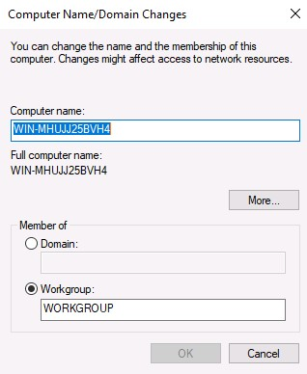

Figure 4.28: Changing the server's name

1. Click **OK** to confirm that you will restart your server to apply these changes.
2. In the **System Properties** window, click the **Close** button.
3. In the Microsoft Windows dialog box, click **Restart Now**.

Now let's learn how to join the server to a domain.

### Joining a domain

Before joining the server to a domain, evaluate the role of your server. If your server is going to be a **Domain Controller** (**DC**), then there is no need for it to join a domain, as adding the AD DS role will automatically make your server a domain controller. Otherwise, if your server is going to have a role other than AD DS, then, as a domain member, it must join the domain as in *Figure 4.29*. To do so, take the following steps:

1. In the **Properties** section, click the highlighted workgroup.
2. In the **System Properties** window, click the **Change** button.
3. In the **Computer Name/Domain Changes** window, select the **Domain:** option and click the textbox to provide the domain name: myorg.local, and then click **OK**:

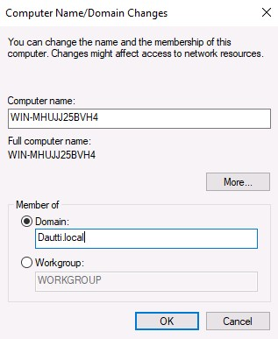

Figure 4.29: Joining a server to a domain

1. In the **Windows Security** window, enter the name and password of an account with a permission to join the domain, and then click **OK**.
2. The **Computer Name/Domain Changes** dialog box welcomes your server to your organization's domain. Click **OK** to close it.
3. Click **OK** to confirm that you will restart your server to apply these changes.
4. In the **System Properties** window, click the **Close** button.
5. In the **Microsoft Windows** dialog box, click **Restart Now**.

Now let's learn how to enable Remote Desktop.

### Enabling Remote Desktop

To enable Remote Desktop, as in *Figure 4.30*, take the following steps:

1. In the **Properties** section, click the highlighted Remote Desktop setting.
2. In the **System Properties** window, select the **Allow remote connections to this computer** option.
3. The **Remote Desktop Connection** dialog box informs you that the Remote Desktop firewall exception will be enabled. Click **OK** to close it:

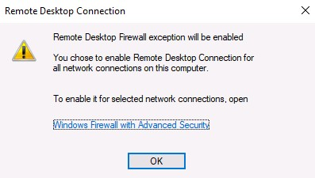

Figure 4.30:

Enabling Remote Desktop

1. To add Remote Desktop users, click the **Select Users...** button.
2. In the **Remote Desktop Users** window, click the **Add** button to add users. Select “Domain Users” from your AD DS. When you have finished adding Remote Desktop users, click **OK** to close the **Remote Desktop Users** window.
3. Again, click **OK** to close the **System Properties** window.

Now let's learn how to set up the IP address.

### Setting up the IP address

To set up the IP address, as in *Figure 4.31*, take the following steps:

1. In the **Properties** section, click the highlighted Ethernet setting:

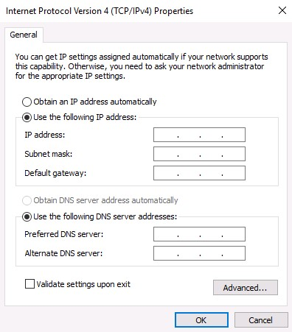

Figure 4.31:

Setting up the IP address

1. In the **Network Connections** window, right-click your server's Ethernet and select **Properties**.
2. In the **Ethernet Properties** window, select **Internet Protocol Version 4 (TCP/IPv4),** and click the **Properties** button.
3. In the **Internet Protocol Version 4 (TCP/IPv4)** **Properties** window, select the **Use the following IP address:** option and enter the **IP address**, **Subnet mask**, and **Default gateway** fields.
4. IP Address: 172.16.0.12  
   Subnet Mask: 255.255.0.0  
   Default Gateway: 172.16.0.1

DNS Server: 172.16.0.10

1. Additionally, select the **Use the following DNS server addresses:** option and fill in the **Preferred DNS server** and **Alternate DNS server** fields. Click **OK** to close.
2. Click the **Close** button to close the **Ethernet Properties** window.
3. In the upper-right corner, click the Close button (the red X) to close the **Network Connections** window.

Now let's learn how to turn off the IE enhanced security settings.

### Turning off IE enhanced security

To turn off the IE enhanced security settings, as in *Figure 4.33*, take the following steps:

1. In the **Properties** section, click the highlighted IE enhanced security configuration setting.
2. In the **Internet Explorer Enhanced Security Configuration** window within the **Administrators:** section, select the **Off** option.
3. Click **OK** to close the **Internet Explorer Enhanced Security Configuration** window:

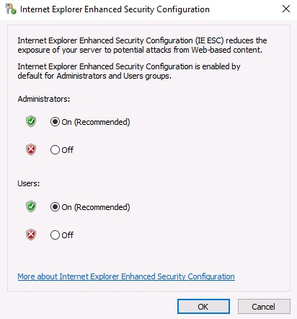

Figure 4.33: Turning off IE enhanced security

Now let's learn how to change the time zone.

### Changing the time zone

To change the time zone, as in *Figure 4.34*, take the following steps:

1. In the **Properties** section, click the highlighted time zone setting.
2. In the **Date and Time** window, click the **Change time zone...** button.
3. In the **Time Zone Settings** window, click the drop-down list to select your time zone.
4. Click **OK** to close the **Time Zone Settings** window.
5. Again, click **OK** to close the **Date and Time** window:

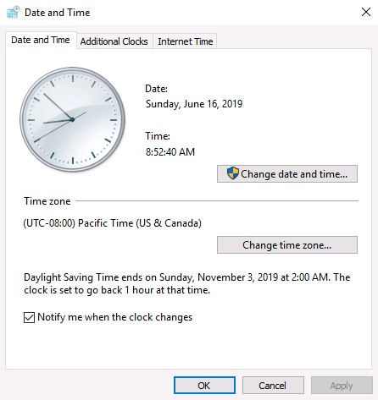

Figure 4.34: Changing the time zone

## Performing Windows Server initial configuration using Server Configuration

The following section explains the initial configuration of Windows Server 2019 Standard (Server Core) using Server Configuration.

1. Start SVR3 and sign in.

### Changing the server name

To change the server name, as in *Figure 4.36*, take the following steps:

1. Enter 2 as a selected option and press *Enter*.
2. Enter the new server name, SVR3 and press *Enter*.
3. In the **Restart** dialog box, click **Yes** to restart the server:

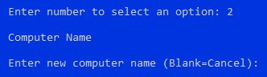

Figure 4.36: Changing the server name

1. Your server will restart so it can apply the server name change.

Now let's learn how to join the server to a domain.

### Joining the domain

Before joining the domain, take into consideration the notes provided earlier, when we were performing configuration using Server Manager. To join the domain, as in *Figure 4.37*, take the following steps:

1. Enter 1 as a selected option and press *Enter*.
2. To join your server to your organization domain, enter D and press *Enter*.
3. Enter your organization domain, myorg.local, and press *Enter*.
4. Enter the authorized domain user and press *Enter*.
5. Enter the password and press *Enter*.
6. In the **Change Computer Name** dialog box, click **No** when asked to change the name of your server:

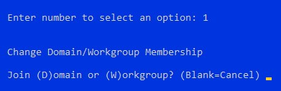

Figure 4.37: Joining the domain

Now let's learn how to enable Remote Desktop.

### Enabling Remote Desktop

To enable Remote Desktop, as in *Figure 4.38*, take the following steps:

1. Enter 7 as a selected option and press *Enter*.
2. To enable Remote Desktop, enter E and press *Enter*.
3. Enter 1 and press *Enter* for more secure access.
4. In the **Remote Desktop** dialog box, click **OK** to confirm Remote Desktop enabling:

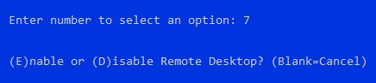

Figure 4.38: Enabling Remote Desktop

Now let's learn how to set up the IP address.

### Setting up the IP address

To set up the IP address, as in *Figure 4.39*, take the following steps:

1. Enter 8 as a selected option and press *Enter*.
2. Enter the number of the network adapter that you want to set up the IP address for and press *Enter*.
3. Enter 1 in the sub-menu to set the network adapter address and press *Enter*.
4. Enter S for the static IP address and press *Enter*.
5. Enter the static IP address 172.16.0.13 and press *Enter*.
6. Enter the subnet mask 255.255.0.0 and press *Enter*.
7. Enter the default gateway 172.16.0.1 and press *Enter*.
8. Enter 2 in the sub-menu to set the DNS servers and press *Enter*.
9. Enter the new preferred DNS server 172.16.0.10 and press *Enter*.
10. In the **Network Settings** dialog box, click **OK** to close it.
11. Enter the alternate DNS server and press *Enter*.
12. Enter 4 in the sub-menu to exit and **Return to Main Menu**:

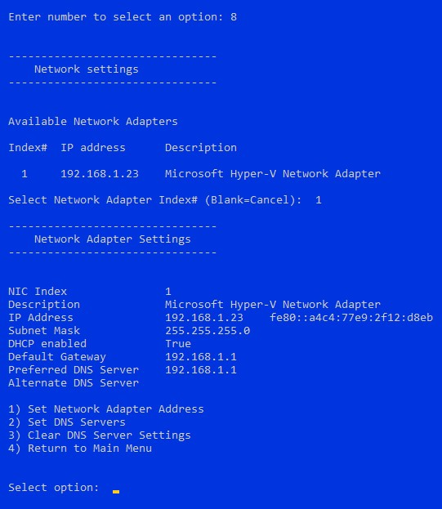

Figure 4.39: Setting up the IP address

Now let's learn how to change the time zone.

### Changing the time zone

To change the time zone, as in *Figure 4.41*, take the following steps:

1. Enter 9 as a selected option and press *Enter*.
2. In the **Date and Time** window, click the **Change time zone...** button.
3. In the **Time Zone Settings** window, click the drop-down list to select your time zone.
4. Click **OK** to close the **Time Zone Settings** window.
5. Again, click **OK** to close the **Date and Time** window:

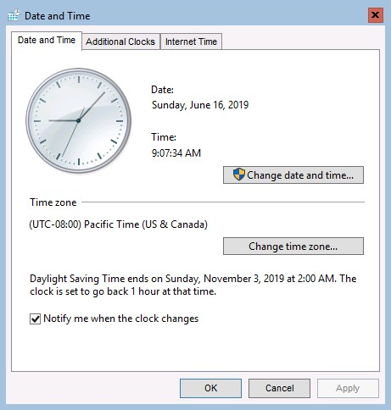

Figure 4.41: Changing time zone